What is it? Edmodo is a secure, social learning platform for students and teachers.

Create an Account

- Go to http://www.edmodo.com

- Click on “I’m a Teacher” button to create an account.

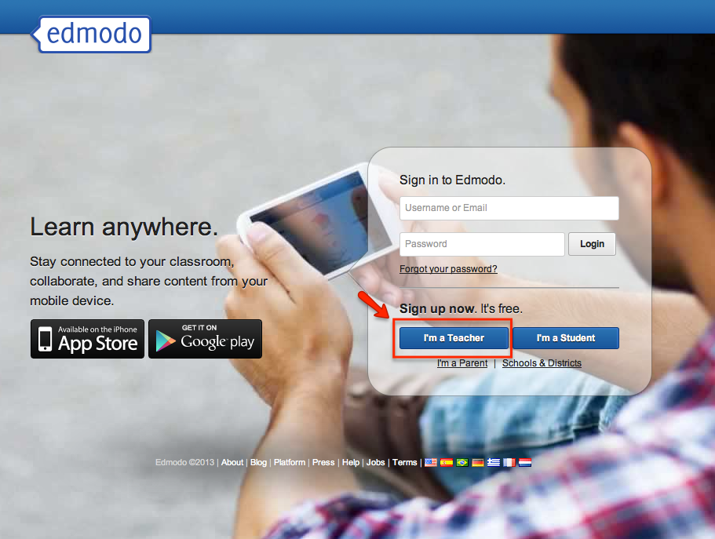

- Complete the registration form and click “Sign Up” button.

- Check your email for confirmation to view the next steps for setting up your account.

Create a Group

- Select the “Create” link in the “Groups” section on the left panel of your Edmodo homepage.

- Enter a group name and select the correct grade and subject area in the pop-up box that appears.

- Click the “Create” button and Edmodo will display a 6-digit group code. This is the group code that you will need to give your students so they can join your group. Groups are listed on the left panel of teacher and student accounts.

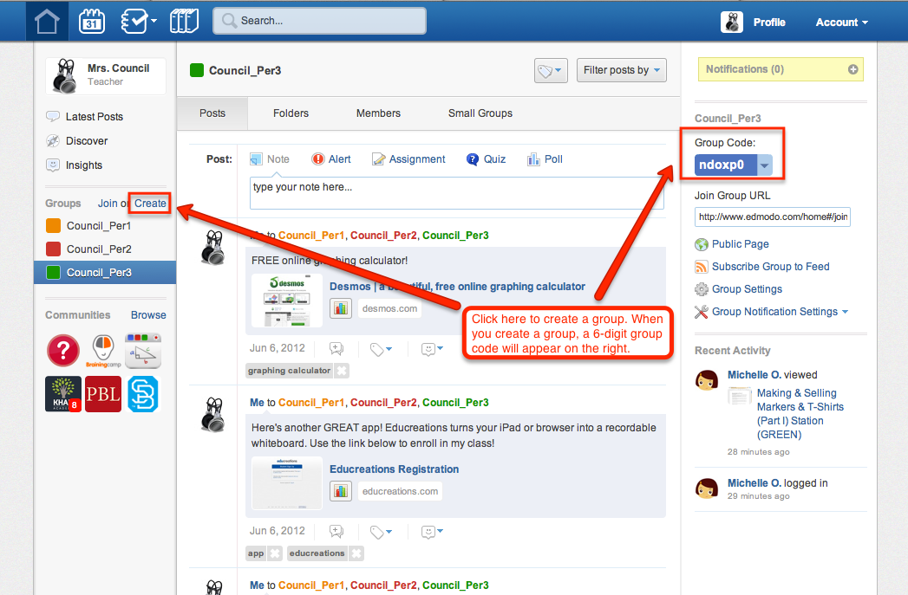

How to have Students Join a Group

- Go to http://www.edmodo.com

- Click on “I’m a Student” button to create an account.

- Complete the registration form with group code and a username and password. An email address is not required for students.

- Click “Sign Up” button.

- The student will then see the group you created on the left panel.

How to Change Group Settings

- Click on the group on the left panel of your Edmodo homepage. The right panel of your Edmodo homepage will display the 6-digit group code and the group management options.

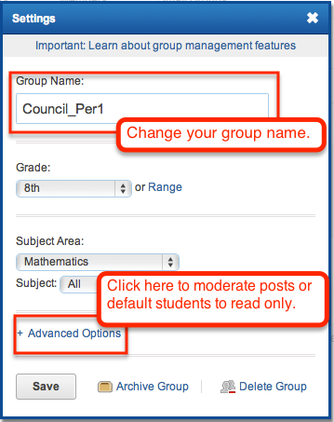
- Select the “Group Settings” link below the 6-digit group code.

- Make appropriate changes as necessary.

How to Manage Members in a Group
There’s so much to know about each student in a class, but how can a teacher possibly keep track of everyone? The “Members” tab allows you to view all members in the group and access a wide range of member information. This tab is useful for retrieving students’ username and changing passwords, as well as parent codes.

- Click on the group on the left panel of your Edmodo homepage.

- Select the “Members” tab at the top of the group’s communication stream. On the Members page you can:

- Set group member status, download and print member account information and parent codes, and view a list of students whose parents have created parent accounts, change student passwords, see student usernames, remove members from your group and award badges.

- Click a member of the group to take the following actions on the right panel:
- Delete that member from the group by selecting the “Remove from Group” button.
- Award that member a badge by selecting the “Award Badge” button.
- Change the member’s password by selecting “Change Password”.
- Retrieve the parent code for that member by selecting “Parent code”.
- Put that member in read-only mode by selecting it from the access drop down menu.
- View the member’s “profile” or “grades” by selecting the appropriate quick link from the right panel.

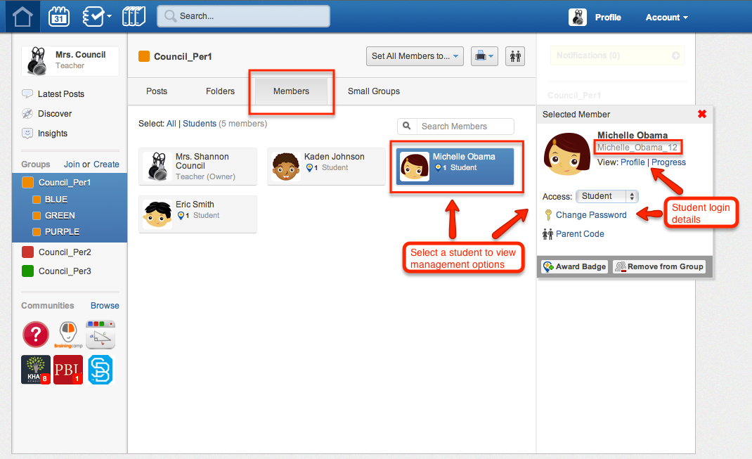

How to Create a Small Group
Want to share different messages for group projects, study groups, or centers? Trying to differentiate assignments for your students? Teachers can create small groups within their main groups to make communication simple! Within small groups, you and your students can post, just as you would to a group.

- Click on the group on the left panel of your Edmodo homepage.

- Select the “Small Groups” option at the top of the groups communication stream.

- Select the “New Small Groups” button at the top right of the page.

- Enter a small group name and click “Create”.

To add members to the group:

- Click on the small group’s name.

- Drag and drop the students from the right panel to the center of the small group page.

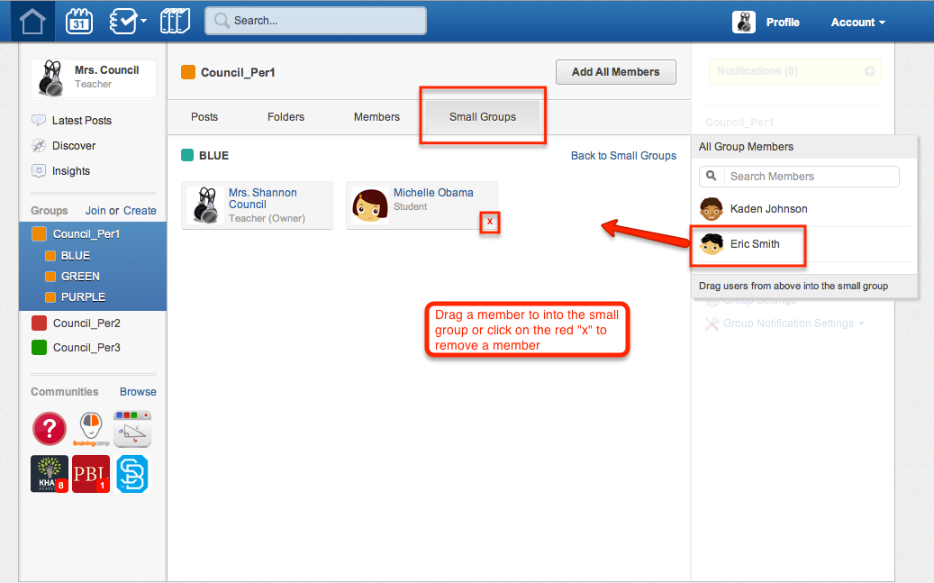

How to Send a Post

- Click on Note, Alert, Assignment, Quiz or Poll at the top of your center panel of your Edmodo homepage.

- Click the “Files,” “Links,” or “Library” link option to upload attachments to your post. (Any files or links you post will automatically be added to your library).

- Choose to Send Now or Schedule the delivery of the post.

- Type of name of the student, teacher, or group into the “Send to” field.

- Click “Send”.

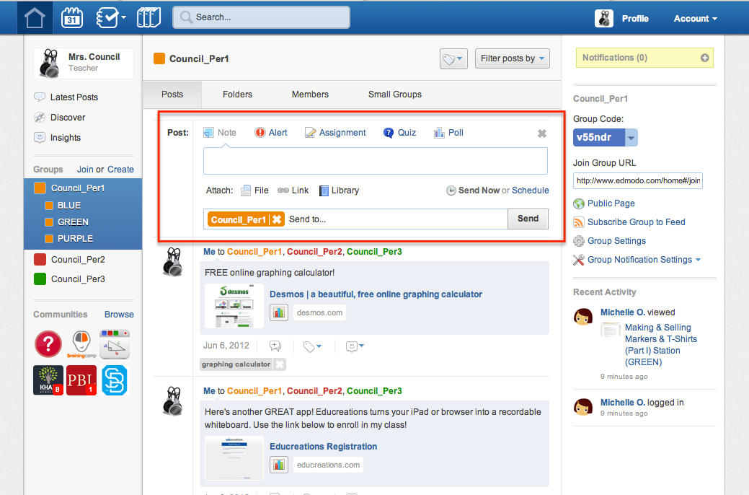

How to Manage and Edit Posts

- Hover over the post or reply and click the blue arrow that appears in the top right corner of the post.

- Choose an option and make the necessary changes.

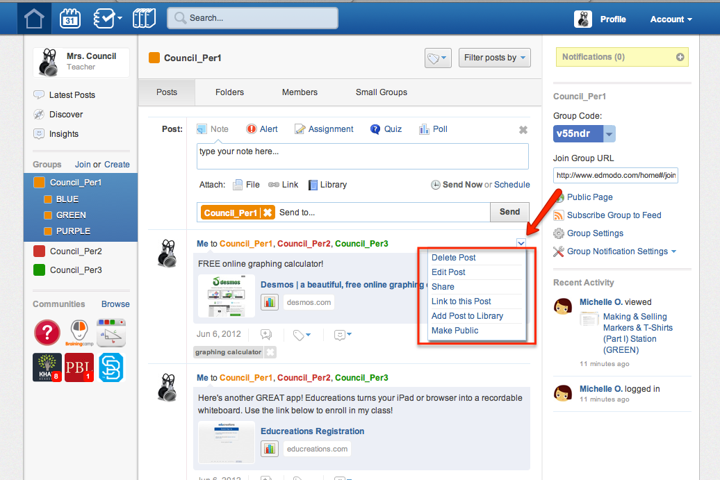

How to Create and Manage Badges
Trying to find ways to recognize your students and keep track of positive behavior? You can easily provide recognition to individual students for their achievements. Badges are simple to award, and teachers have the option to choose pre-made designs or create their own.

- Select the group name from the left panel.

- Click the “Members” tab located on the group navigation bar.

- Select the student you wish to award a badge to and from the right panel, select the “Award Badge” button.

- Select multiple students to award multiple badges at once.

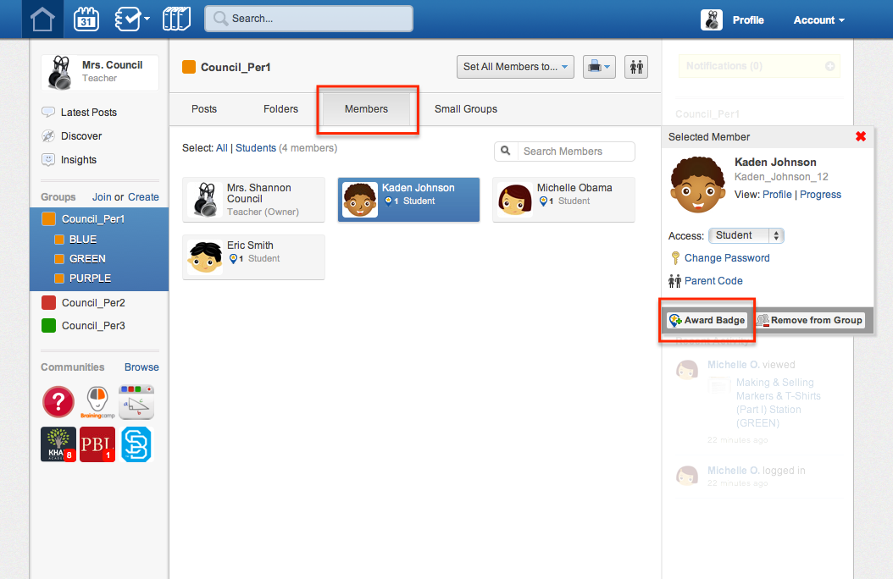

Find more helpful tips at http://help.edmodo.com.

